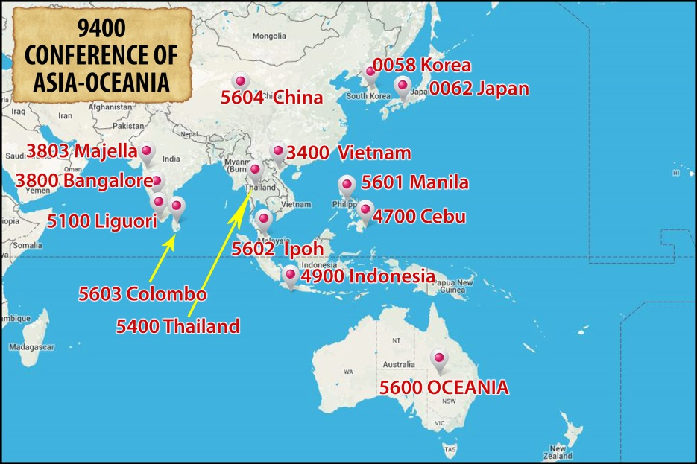

FORMATION

Present Reality and Initiatives
The Conference of Asia-Oceania celebrates the great strides it has made in terms of collaboration among Units at all levels of initial formation.
Among them are: the Inter-Unit Novitiates in Lipa in the Philippines and Kotagiri in India, Inter-Unit Theologates at SATMI in Davao in the Philippines, Bangalore in India and an international Theologate in Kew (Yarra Theological Union) in Australia and common Programs for Preparation for Final Profession. Programs and Ratios have been developed for all of these. Oceania organized a Symposium on Transition to Ministry held in Perth, Australia. There has also been regular ongoing formation for brothers.
These efforts in collaboration are certainly one of the real successes of the Conference.
Challenges
  - The promotion, formation and identity of the Brothers vocation is one that needs urgent attention.
  - Given the demands of mission in modern society, the challenge is that Units plan programs of Ongoing Formation, updating and training in various fields in order to carry out the apostolic priorities of Units and the Conference. Every confrere is also challenged to be open to personal renewal and welcome opportunities for Ongoing Formation as they occur.
  - The stage of Transition to Ministry has become an essential stage in formation. The challenge for all the Units of the Conference is to develop programs in collaboration with one another to best help our young confreres to be effective in the mission of the Congregation.
  - There is a need to train formators and academic faculty for all the stages of Formation.
  - We are challenged to provide good and timely formation for our lay partners in their identity, mission and charism.

