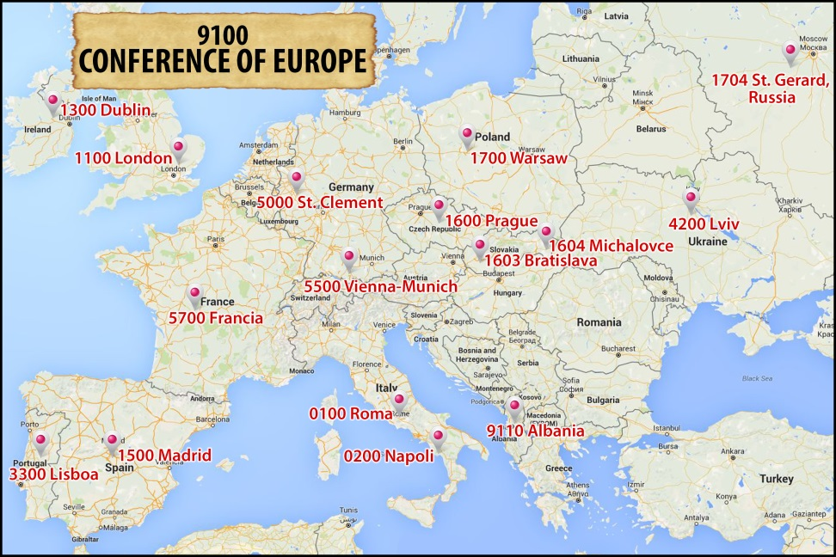

FORMATION
- What are the common Formation Programs in the Conference?
- Initial formation

Previously there was the Common Ratio Formationis for Europe South and the respective Ratios for other Units in Northern Europe. Currently, we are preparing to implement the decisions of the General Government from 2015. Many preparations are in progress.

(for the whole of CRE)
- Common preparation for Perpetual Vows in the CRE:

- Tuchów (Poland) 2013 (4 UNITS - 8 students: Warsaw, Lviv, Rome, Naples;)

- Tuchów (Poland) 2014 (13 students from [7 UNITS] different countries of Europe: Slovakia, Ukraine, Great Britain, Germany, Italy, Spain and also 4 from Zimbabwe in Africa);
- Tuchów (Poland) 2015 (13 students from 5 UNITS: Warsaw (5), Lviv (4), Madrid (1), Bratislava (1) and The Region of Zimbabwe (2).

- Kostolna (Slovakia) 2016 (……
- The Alphonsian Pilgrimage for those in initial formation: 17.08 - 22.08, 2014 in Italy; for our seminarians from various Units in Europe.

(for some Units together)

- Yearly retreats, days of recollections, symposiums, etc. (among the Units with the same or similar languages).

b. Ongoing formation

(for whole the CRE)
- Summer course for those in the Transition to Ministry program - this course lasts two weeks and is for confreres less than ten years perpetually professed.

- Tuchów (Poland) 2013 - 4 Fathers from the Warsaw Province;
b) Tuchów (Poland) 2014 - 2 Fathers from Italy and 8 from Poland have participated in the first weeks of the course, as they celebrate the 10th anniversary of their perpetual vows;

c) Tuchów 2015 - 14 confreres who were ten years professed or ordained: 11 from the Province of Warsaw, 1 from Saint Gerard Region and 1 from the Province of Lviv and the Major superior of the Vice Province of Michalovce.
d) Kostolna (Slovakia) 2016 - ….

- Common meetings of formators:

a) Meeting of Formators and Formandee from Region of Europe South: Colle Sant’Alfonso (Italy) 2012;
b) Meeting of Formators from the Region of Europe North: Lubaszowa (Poland) 2012;
c) First Common Meeting of Redemptorist Formators from the CRE: Krakow, (Poland) 12-16.07.2013 - There were 33 formators from almost all Units;
d) The Second Common Meeting of Redemptorist Formators from CRE: Dublin (Ireland) 1-5.09.2015 - 25 formators from 12 Units of the CRE and 1 from North America.

- Meeting for the Brothers from the CRE: Vienna 09.-13.09.2013

(among some Units)

- Yearly retreats, days of recollection, symposiums (these meetings are based on common languages: Slavic languages, English, Italian, Spanish, Portuguese, German).

- What are the common Formation Programs between your Conference and other Conferences?

- Initial formation

Some students from Africa participated in the common preparation for perpetual vows in the CRE (2014; 2015).
Some Novices from Europe participated in the Novitiates in: Africa, North America and South America.

- Ongoing formation

One formator from North America took part in the common meeting of the formators from the CRE in 2015.
- What are the concerns and needs of the common Formation Programs? Why?

- Respecting diversity in Europe - how can we work to devise a common theological and pastoral vision of Redemptorists of Europe?
- How do we prepare candidates for our Redemptorist way of life? In more than the half of the Units in CRE there are no formandee at all while in others the number is very small.
- Lack of candidates in some Units – the small number involved make it difficult to provide a viable formation program. Lack of vocational discernment programs in some Units.
- Lack of formators who can be given by the Units for common formation programs. Also there is an extremely limited number of confreres capable of taking on formation roles in the Units.
- Some Units fear the impact on vocations work of the Unit when the formandee go to other countries or to other regions in the same country for formation.
- What are the challenges facing our common Formation Programs? Why are these perceived to be challenges?

- difficulties connected to the various places of origin of the formandee (the Redemptorist way of life is different in various places on the same continent – it causes some problems);
- difficulties connected with the different ages of candidates who start initial formation;
- problems with different languages;
- there are some challenges connected to the use of digital forms of information, internet etc. (there are different ways of resolving these problems in various Units – we do not have the same vision: how to do it?);
- individualism of candidates, the impact of secularism;
- the normal challenges of living the vows and the sense of entitlement that is prevalent throughout the entire society;
- there is a big challenge in forming good formation teams;
- some confreres do not wish to participate in common programs of on-going formation – they have some fears;
- Is there a common Ratio for formation in place where there are common Formation Programs?

on the CRE level:

- There is a common Ratio Formationis for the former Region of South Europe and for the Common Novitiate in Europe South.
- There are the agreements between some Units about common formation programs (Naples and Rome; Warsaw and Michalovce and The Region of Saint Gerard, etc.)

- Are there Orientations/Guidelines/Resources for lay collaborators in your Conference?

- Many Units have something like Orientations/Guidelines/Resources but in various forms (e.g. Naples: “Direttorio ad experimentum per la realtà dei LAR”; Bratislava and Prague: Common Formation Programme for Lay Collaborators; Lisbon: the courses of “Centro de Espiritualidad Redentoristas”; St. Cement Province: two-years program for Associate Members; Bratislava: some parts of the Plan of Community Life (in every community) are dedicated to collaboration with the Laity.
- Some Units are working on this: (e.g. Rome; London), some Units do not have it at all.
- Some Units are considering establishing a “school of mission” (Dublin).
- In many Units: lay collaborators meet regularly and they have regular in-service training days (Dublin); annual meetings in El Espino (Madrid).
- There is the Academy of Clement Hofbauer with special programs and formation (in the Saint Clement Province).
- Are there regular meetings for lay collaborators at Conference level?

Until now there has been one meeting for whole the CRE - The First Interprovincial Meeting of Partnership in Mission of the CRE in Madrid from 11th to 13th December 2015. It provided a vast perspective of present collaboration with lay people in the CRE.

