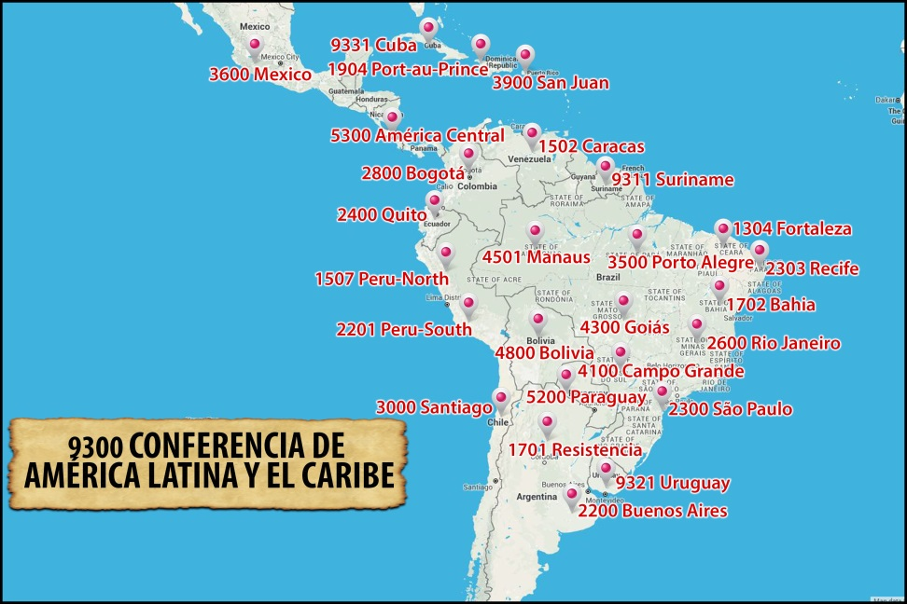

FORMATION

Formation is one of the priorities of the Conference, especially the area of ​​vocational ministry. To build a vocational culture it is necessary for all pastoral work to lead into promoting vocations.

The year dedicated to Redemptorist missionary vocations was particularly significant for us because, along with encouraging us to deepen the mystery of our own vocation, we organized ourselves better in this area, especially by incorporating the laity. The different Units have a promoter or vocational team consisting of confreres and laity who take care to encourage the implementation of various programs of vocational promotion. These promote, through monthly meetings, vocational discernment among children and youth, who are subsequently accompanied, individually and corporately, as required by the process they are living.

It is true that at some point in the past, vocational promotion was more focused on the priestly ministry. But today is very different. The vast majority of the Units emphasizes and deepen the Redemptorist missionary religious vocation.

Religious Brothers in the Congregation give everyone a clear testimony of being a missionary in the Redemptorist identity. This is promoted from the same initial formation. Recalling the history of the meetings of Brothers (CLAHER-CLAIR), which is held every three years (for the last 25 years), we realized that the meetings have taken place at crucial moments in the history of Latin America and the Caribbean and the Congregation. They have taken place before and after General Chapters, significant for the Congregation, before and after the Episcopal Conferences of CELAM (eg, Santo Domingo, Aparecida) and currently in the Jubilee of the Icon of Our Lady of Perpetual Help and after the year of vocational promotion. The results of the meetings have been very prophetic in their reflections and proposals, and the study of related topics, for example, RESTRUCTURING, the IDENTITY and the SENSE OF BELONGING in the Consecrated Life, REDEMPTORIST SPIRITUALITY, HUMANIZATION, the concept that the Redemptorist MISSION is ONE, etc. The Conference reflects on the importance of promoting the vocation of the Redemptorist Brother and the feasibility of a common center for the formation of Brothers. There is a need for a plan and a directory for the ongoing formation of the Brothers.
All Redemptorist formation is based on the person of Jesus Christ, on how to build community life, the experience of God, living the vows and evangelization as a witness.

We emphasize the fact that the Units have been developing their Formation Plan based on the Ratio Formationis. But these plans have to be constantly reviewed because the reality in which the young unfolds always presents new and different challenges for formation. Some of these challenges are: the emotional and affective immaturity of the candidates, which hinders their perseverance; family disintegration; the ecclesial crisis, to which for our part we must add the lack of prepared formators to give continuity to the process.

Within the Conference, there are several stable interprovincial formation structures, such as, for example, the Novitiates of URNALC and URSAL; a preparation program for final vows; courses and accompanying of the young consecrated confreres; meetings of the various areas of life (spirituality, laity, mission, formation, etc.). There are also processes and dialogues already initiated in view of new initiatives such as: the establishment of interprovincial theologates; Formation of religious Brothers in the interprovincial context and exchange of personnel for itinerant missions. It is perceived in Initial Formation the need for greater communication and interaction between the Units of each Sub Conference.

The Units recognize the call some lay people receive to live their Christian lives according to the Redemptorist charism and Redemptorist spirituality in shared mission with the confreres. For some of our Units, the subject of lay associates is just beginning and requires further deepening. In other Units, collaboration is well advanced to the point that missions and provincial works are shared. Some Units have developed directories that guide communion and integration between the laity and the confreres. In one of the Sub Conferences, a formation program for the laity has been developed. This program can be modified according to the reality of each Unit. In some Units, the laity have joined the vocation promoter constituting a vocational team to encourage the implementation of various promotional programs. Some schemes and concrete achievements are urgently needed in the preparation and ongoing formation of our laity. It is also essential to work in the formation of the confreres to learn to work with the laity, side by side, in shared mission.

