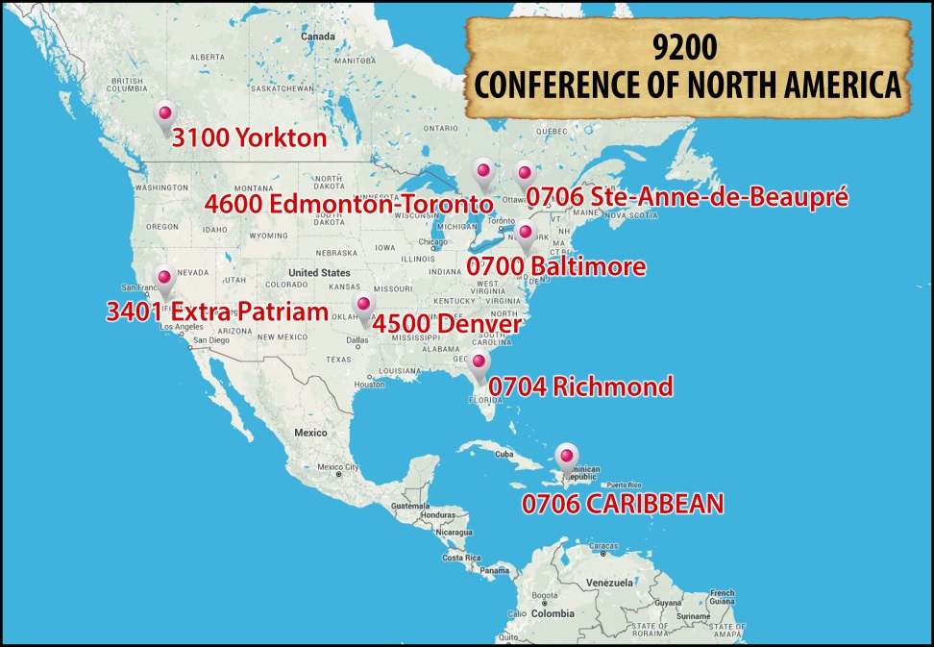

FORMATION

- What are the common Formation Programs the Conference?

a. Initial Formation
- Redemptorist Residence, Bronx, NY (Philosophy)
- Novitiate, Toronto, Canada
- Shared Theologate (under discussion)
- Annual student gathering
- Summer pastoral assignments
- Pastoral Year assignments
- Transition to Ministry in the USA
b. Ongoing Formation
- Conference-level retreats
- Conference-level historical seminars
- Formation courses
- Workshops using experts from other Units

- What are the common Formation Programs between your Conference and the other Conferences?

a. Initial Formation
- Novitiate

b. Ongoing Formation
- Conference-wide retreats
- Conference-wide historical seminars

- What are the concerns and needs of common Formation Programs? Why?

- A Conference-level Theologate. A Ratio is being worked on so that we have a shared vision of Formation.
- A Conference-level Philosophy Ratio needs to be created so that we have a shared vision of college formation. Currently, each Province has its own philosophy ratio even though the students are living in the same community.
- A Conference-level program for the Preparation for Final Vows is being discussed.
- Currently, we have multiple financial contracts for interprovincial communities. We are discussing creating a unified contract that will be standard for all Conference arrangements.

- What are the challenges facing the common Formation Programs? Why are they perceived
to be challenges?

- Having men from different cultural and regional backgrounds.
  - This particular point has two sides. Getting men from different backgrounds together is a source of tension because of different expectations, meeting styles, and even food preferences. At the same time, by working through these issues, our formation programs become witness to the ability to respect and work together in the face of cultural differences.
- Different levels of formation have different lifestyle approaches. This creates different expectations as to the availability of cars, financial resources, and even the seeking of permissions.
- Because houses of formation are in different countries within the Conference, we are faced with many visa and immigration situations. Explaining a “Novitiate” to customs agents is especially perplexing.
- Despite the merger of many formation programs, the overall costs are still very high and a burden to the Units.
- Creating formation programs that are not looking to train a “generic Redemptorist” but are instead respectful of the various cultural differences.

- Is there a common ratio for Formation in place where there are common Formation
Programs?

- Novitiate has a common ratio.
- The philosophy program has a shared understanding and is discussing a common ratio.
- A common ratio for the Theologate program is being created for approval at the next Conference Assembly.

6. Is there a Formation Program for lay collaborators at the Conference level?

- A Conference-level Secretariat for Partners in Mission was formed to address this issue. This secretariat is designing a program based on the material created by the General Government. Currently, Anne Walsh, a Partner in Mission of the Edmonton-Toronto Province is studying for a Doctorate in Ministry (D.Min.) with a specific focus on the Redemptorist Partners in Mission and is designing a formation program.

The Analytical Reflection (Formation)

Houses of formation that cross provincial boundaries have been happening for decades in North America, and in general these experiences have had difficulties. A current exception to this has been the novitiate. This positive experience has been a model for discussing cooperation with other levels of formation. This coming year, the Extra-Patriam Vice-Province will be joining the Conference novitiate program.
Besides the Novitiate, the Conference is working on the following areas of Formation:
- the interprovincial assignments of students for their pastoral experience
- the interprovincial program for the Preparation for Final Vows
- the decision to create a Conference Theologate
Despite our corporate memory of difficulties with the formation across provincial lines, all of our students have a very positive view of interprovincial formation and express a desire that it continue to develop on all levels. It is clear that the next generation of Redemptorists will view our Congregation as a Worldwide, Conference and Provincial reality.

