“Be holy, be happy”: Feast of Blessed Francis Xavier Seelos
October 4, 2020

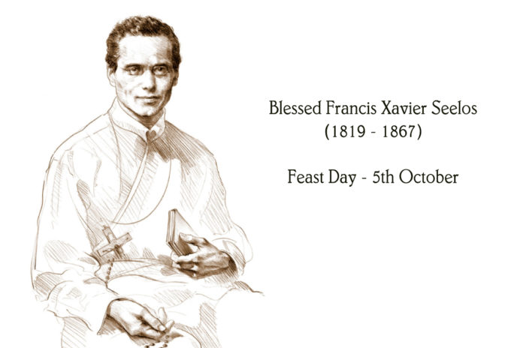
We, the Redemptorists all over the world commemorate the feast of Blessed Francis Xavier Seelos on 5th of October. He was beatified by John Paul II in 2000. The national shrine of Blessed Francis Seelos is in the Church of St. Mary’s Assumption, New Orleans, Louisiana.
Francis Xavier Seelos was born in Fussen, Bavaria, on January 11, 1819. He studied philosophy at the University of Munich and began theology as a seminarian for the diocese. Visiting the Redemptorists in Altotting, he heard of their missionary work in North America and decided to join them. With their approval, in 1843 he set sail for the United States, where he made his novitiate. In 1844, Seelos professed vows as a Redemptorist and was ordained a priest in Baltimore. His first assignment was to St. Philomena Parish in Pittsburgh. He served there for six years as assistant pastor with John Neumann, followed by three years as superior of the community. During this time he was also the novice master. In 1854 he was transferred to Maryland first to Baltimore, then to Cumberland in 1857, and to Annapolis in 1862, all the while engaged in parish ministry and serving in the formation of future Redemptorists as prefect of students. Replaced as prefect in 1863, he preached missions in German and English throughout the northeast and mid-west United States. Seelos was always an active and highly successful missionary, particularly devoted to the ministries of reconciliation and spiritual direction. In 1866, after a year in Detroit, Michigan, he was made pastor of St. Mary’s Assumption Parish in New Orleans, Louisiana, where he devoted himself to the poor, sick, and neglected. While caring for victims of yellow fever, he contracted the disease and died on October 4, 1867.
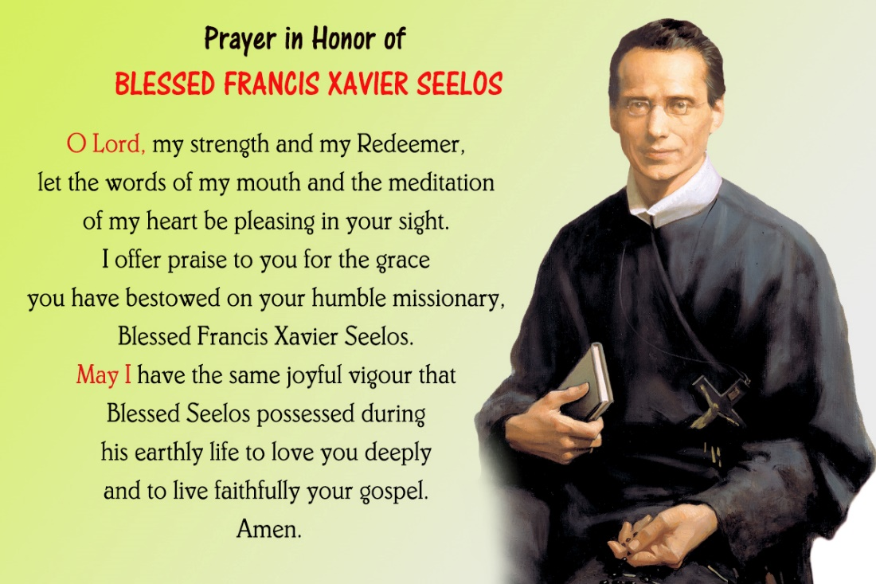
His biography is titled: “Cheerful Ascetic”. An ascetic is usually a person who is serious looking because his sacrificial life. But Francis was a cheerful person. He was a friendly person who enjoyed jokes…So, his message to you and me would be: “Be holy, be happy!”
O Blessed Francis, help us to live as happy messengers of the gospel.
View the Website of the National Shrine of Bl. Seelos: www.seelos.org

