Vocation ministry and accompaniment
May 22, 2020

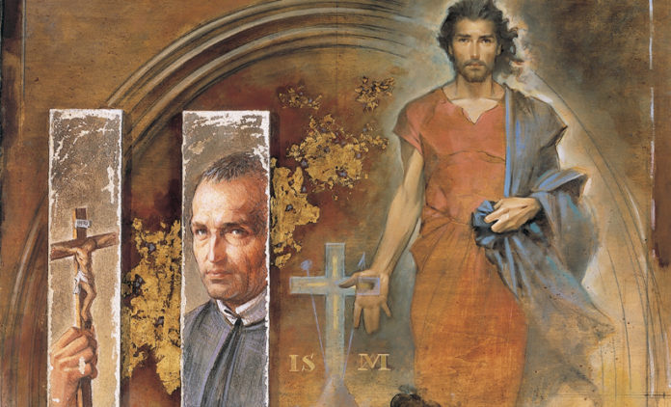

There is a real possibility of a surge in vocations to the Priestly and Religious life, especially Redemptorist vocations, after this time of COVID-19.
What is the basis of this possibility? Many years ago, in the late ‘80s, a well-known Jesuit ministering in the Dominican Republic, Fr. Jorge Cela, S.J., anthropologist, gave the Redemptorist formators a talk on vocations He mentioned first of all that young people are idealistic and dream of a better, more just world. In historical times when governments, economics, military, and other social wellbeing services fail a population, the lives of Religious, as credible agents of change, became extremely attractive. This was very evident after the French revolution in 1789, after the Second World War, and in many countries of Latin America after the era of dictatorships. Of course, an essential element of this phenomenon are families who offer strong testimony of living faith, and not limited to the parents, but also grandparents, aunts, uncles, godparents, etc.
As we analyze what is and has happened during the pandemic COVID-19, we see that the “first responders” and health professions have been recognized for their dedication and bravery on the front lines of defense and service to their fellow human beings. Many youths now find these professions attractive, as agents of change, and testimony of the higher values of humankind, among them, being the service to and the love of neighbor. Many youths will now aspire to these professions.
As we look around the world and the response of Religious to COVID-19, we can be proud of how our Redemptorist family has responded. Each continent and each Redemptorist Conference have given strong testimonial examples.
Of the many media outlets, for example, Facebook, YouTube, webpages, bulletins, etc., that have communicated some of the Redemptorist actions, we add examples written about and published on the Redemptorist blog-page, http://www.cssr.news//blog/1/ In this article, just two of the many responses from each Conference are presented.
For those who are directly ministering and those interested in the vocation ministry of the Redemptorist Family, may we suggest the promotion and making known these worldwide Redemptorist responses. These actions reflect the dynamic and attractive credibility of the Redemptorist Charism and Spirituality of serving and preaching the good news to the poor and abandoned.

CONFERENCE OF EUROPE

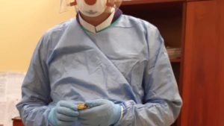
Hospital ministry, Warsaw, Poland

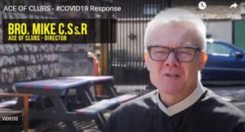
Homeless ministry in London, England

CONFERENCE OF NORTH AMERICA
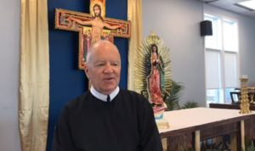
Preaching the Good News: Missions, “Padre Migrante”, Mike Andrews, C.Ss.R.

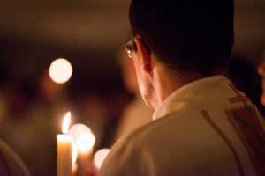
Hospital Chaplaincy, St. John’s NL, Canada

CONFERENCE OF LATIN AMERICA AND THE CARIBBEAN
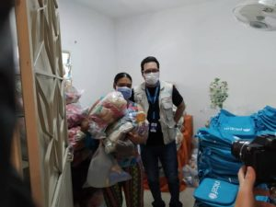
The distribution of food, hygiene kit, and educational materials, Venezuela.
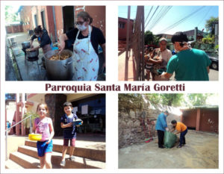
Invitation to rethink the way we live in our common home, the way we produce, consume, and relate to each other and the environment, Paraguay.

CONFERENCE OF ASIA AND OCEANIA
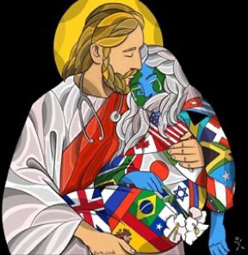
Organization and publication of pastoral guidelines, Cebu Province, Philippines
The distribution of hygiene kits and food packs to street dwellers and others in need by the Redemptorist Formation Community of Davao, Philippines
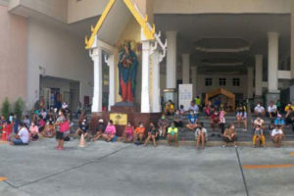
Food distribution, Thailand

CONFERENCE OF AFRICA
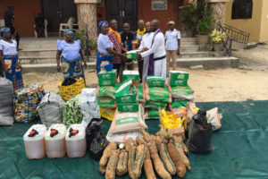
Distribution of food items, (Vice) Province of Nigeria
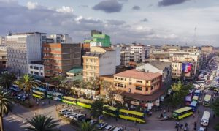
Kenia and Bukina Faso, Africa

Ministry of the “pen”, following the example of Saint Alphonsus:
- Series of articles on mental health during COVID-19 by Dr. Rose Nina, Ph.D., psychiatrist, and Redemptorist lay collaborator
- Series of articles by Dr. Anne Walsh, Redemptorist Lay Missionary
- St. Alphonsus in times of famine and epidemic, by Fr. Grimaldo Garay, C.Ss.R.
- Good Shepherd Pictures today by Fr. Tony Bidgood, C.Ss.R.
- Series of inspirational articles by Fr. John McKenna, C.Ss.R.
- Series of articles on Moral Theology and Spirituality by Fr. Rogerio Gomes, C.Ss.R., General Consultor
- The Alphonsian Academy in Rome has published in their bulletin a series of relevant moral theology and spirituality articles during this time of COVID-19 (newsletter@alfonsiana.org).
- The many, many articles of Redemptorist in action in the bulletins and webpages of the Congregation’s Units.
The use of modern communications media:
- ScalaNews web page has an abundance of articles, videos, and resources relating to the Redemptorist response to COVID-19.
- Practically every Unit has made liturgical services available through the internet during the time of closure of our Churches and Shrines, including the Church of St. Alphonsus in Rome, the Shrine of the original icon of Our Mother of Perpetual Help which has transmitted by YouTube not only the Shrine’s liturgical services but also, for contemplation and prayer, a 24-hour streaming service of the original icon of Our Mother of Perpetual Help.
- For World – a multimedia project of the students of the Redemptorist Major Seminary in Tuchow, Poland to promote the Redemptorist spirituality and mission. The project was launched a few weeks before the Covid-19 outbreak.
VIDEOS:
- Series of message videos by Fr. General, Michael Brehl, C.Ss.R.
- The message of Hope from Bolivia
- Reflections offer Hope during the Pandemic, St. Gerard community in Baton Rouge
- Stations of the Cross – Then and Now by Fr. Denis McBride C.Ss.R.
- Series of Lenten and Pascal time Retreats, Baltimore and San Juan Province
- Response to Fear, Fr. José Rached, C.Ss.R.

Manuel Rodríguez Delgado, C.Ss.R.
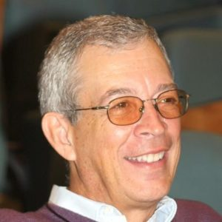
Manuel Rodríguez Delgado, C.Ss.R., from the San Juan Province, is the executive secretary of the General Secretariat of Formation. He, with Father Grzegorz Ruszaj, C.Ss.R., Director of the Congregation´s Office of Communications, have dedicated many hours to the construction of the blog/webpage (Facing COVID-19…) and the translations of articles.

