“A Priest is…” by Dennis Billy, C.Ss.R. of the Baltimore Province

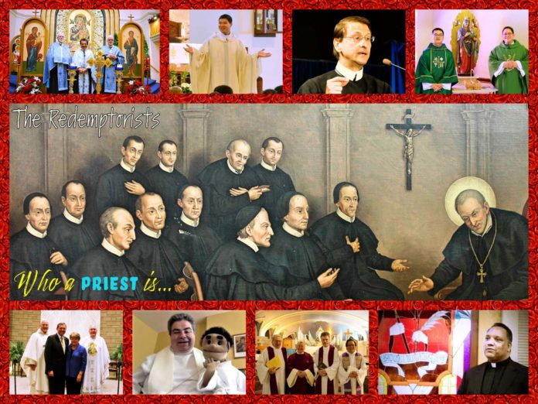Collage of pictures by Fr. Charlie Wehrley, C.Ss.R. which represents Redemptorist priests from all Provinces in North America.

A priest is a man of God. He follows the way of the Lord Jesus. He lives his life for the sake of the kingdom. He sees things the way Jesus sees them. He is someone who thinks before he acts, and who prays before he thinks. He counts his words and means what he says. He speaks from the heart and puts his words into action. He is a man for others, someone who seeks to serve rather than be served. He treats everyone as a brother or a sister. He is a friend of the poor and marginalized. He extends a helping hand to them and actively seeks their well being.
A priest stands up for what is right. He speaks the truth. He exhorts others to do the same. He celebrates the sacraments with simple dignity. He baptizes, “In the name of the Father, and of the Son and of the Holy Spirit.” He is called to sacrifice and to offer sacrifice. He celebrates the Eucharist and invites others to partake of Jesus’ body and blood. He prays for the community and on behalf of it. With his arms extended in prayer, he embraces both the whole world and his small part of it. He gives witness to Christ in both life and death. He sees beyond the present dimensions of time and space. He yearns for the coming of the kingdom and looks for it both within his heart and in his midst.
A priest celebrates life. He also celebrates death. He senses death in the midst of life, and life in the midst of death. He helps others both to celebrate life and to mourn its passing. He helps others to grieve the loss of those they love and to live in hope of one day seeing them again. He knows when to listen when to offer a word of comfort, and when simply to sit in silence. He is not afraid to bow his head, to shed a tear, or to hold somebody’s hand in prayer. Nor is he afraid to smile, to laugh, or to lighten people’s hearts. He believes that love is stronger than death, and that love is the only reason worth living for. He is a man of faith, a man of hope, a man of love, a man of joy.
A priest is human. He sins. He knows what it means to be lonely. Sin and loneliness both humble him and encourage him. They weigh him down but also challenge him. They make him weak, yet also strong. They help him to feel the pain of others and to suffer with them in their daily trials. They bring him to his knees, and to the conversion of heart. He confesses his sins and receives God’s forgiveness. He befriends his loneliness and discovers solitude of heart. He asks for forgiveness, learns to accept it, and also how to extend it to others. He befriends others, allows others to befriend him, and builds with them the family of God. He is an inviting and welcoming presence. With him, there is always an extra place at the table of the Lord.
A priest is a man of the people. He comes from them and goes back to them. He listens to their stories. He ponders them. He helps them find their voice. He helps them discover meaning in their lives by showing them how to recognize the hand of God in all that happens. He journeys with them through life, reminding them of both their origins and destiny in God. He teaches them both how to pray and how to listen. He shares his life with them and allows them to share their lives with him. He makes himself a part of their story and invites them to become a part of his. He enjoys the company of others. He recognizes their gifts and encourages them to be used in service to others. He lives to serve others and to offer his life on their behalf.
A priest is a man of God. He is a father, a teacher, a healer, and a leader. He uses his talents for the sake of others. He draws attention not to himself, but to God. He is an apostle, a disciple, a follower of Christ. The cross is his symbol; the empty tomb, his hope; the Church, his home; the people of God, his family. He is the salt of the earth. He gives flavor to people’s lives and tastes to the moments that fill it. He is both their friend and God’s friend. He lives the Gospel and is willing to die for it. For him, there is only Christ. Nothing else matters. Nothing else concerns him. He is a priest, a man of God, a friend of the poor, a person to trust, and to count on, another Christ. He yearns to love and to be loved. He is willing to lay down his life for his friends. He is a priest, a man of God. He follows the way of the Lord Jesus.
Dennis J. Billy, C.Ss.R.

