Alphonsian Spirituality and Spiritual Direction by

Dennis Billy, C.Ss.R.

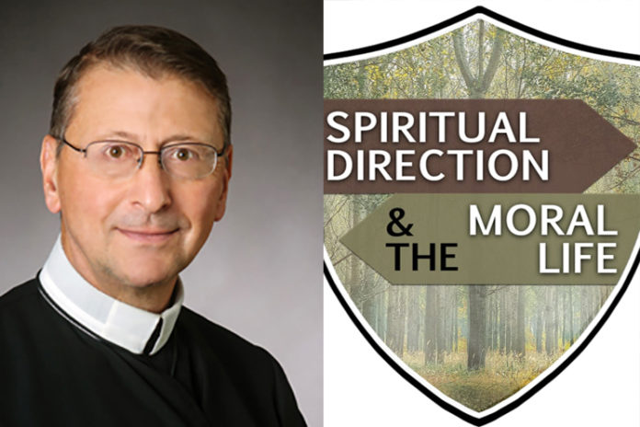

Presented here is a significant resource for Alphonsian spirituality and Spiritual Direction.
A few years ago, Father Dennis Billy, C.Ss.R., received a Templeton World Charity Foundation grant to explore the topic, “Spiritual Direction and the Moral Life.”
The result of his work is a book and a video series by the same name, “Finding Our Way to God”, which takes St. Alphonsus’s approach to mental prayer and adapts it to the spiritual direction process.
This resource is certainly a helpful tool for formators and Redemptorist spiritual directors.
Father Billy has announced that Redemptorists and their Associates can now have free access to the videos (which are in English with Spanish subtitles). Please click on the following for the process of accessing the videos.
Free Access to Finding Our Way to God:
Spiritual Direction and the Moral Life
- Access this link: https://vimeo.com/r/2MUz/aHVUMXFhVm
- The code is COVID19 if you need it.
- Create a new Vimeo user account with an email address you haven’t used before.
- Create and enter a password of your own choosing (at least 8 characters, 1 capital letter and 1 symbol).
- To share, send the link to a friend and have them put in their name, their email address, and a password of their choosing (at least 8 characters, 1 capital letter and 1 symbol), and it should open fine.

