c) 8 Steps to Being a

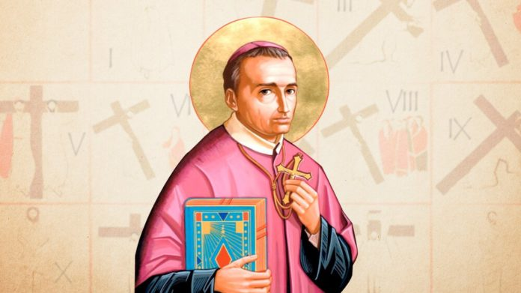
Redemptorist Missionary

Choosing a path, discerning our vocation is not always easy. Many challenges may present themselves and it is often difficult to be clear about the steps to take until, effectively, “getting there”. For those who choose the religious life is no different. Get to know the vocational and formative journey of the Redemptorist Missionaries in eight steps:

1- Feeling the call of God for the religious life
The understanding of the vocation happens through personal growth and maturation as a Christian. This is done through constant prayer, participation in the community and the Eucharist. These three pillars are the basis for the young person to respond consciously to the call of God.
2- To know about the various charisms of the Church
The Catholic Church is rich in gifts and charisms. Many congregations, institutes, and communities are scattered throughout Brazil and the world, each with a different history and mission. It is important for the young person to search for these religious families and to know those that arouse their interest according to the areas of activity. Discerning is knowing!
3- Making contact with the Redemptorist Vocation Ministry
When realizing that the Redemptorist Religious Life can be his way, it is necessary to make contact with the Vocation Ministry to begin the vocational accompaniment. In this first contact, you are asked for some basic information such as age, place of residence and schooling. With these data in hand, the Redemptorist Congregation sends the young person to the nearest Redemptorist unit.
4- Start the vocational accompaniment
After analyzing the data, the candidate is invited to initiate the vocational accompaniment. This is a great opportunity for the vocation to know better the charism and the mission of the Redemptorist Congregation. Usually this process lasts approximately one year and is done through internet training and participation in vocational meetings.
5- Participate in vocational meetings
The meetings are fundamental for the continuity of the discernment process. These are unique moments in which young people have the chance to live with Redemptorist Missionaries for a few days, sharing experiences and getting to know more closely the routine of a formation house. It is important to remember that no one joins the Redemptorist Congregation without having participated in vocation meetings.
6- Joining the Redemptorist formation
After the accompaniment, being considered fit to experience the formative experience, the candidate is welcomed in a house of formation. The long-awaited moment of entering the seminary has arrived. Vocational discernment continues throughout the formative process, which lasts an average of 10 years.
7- To assume the Redemptorist mission as a goal of life
Every new day is a new opportunity to learn more about the community life and about the Redemptorist Mission. This is the purpose of the formative journey, which assists in the confirmation of the Redemptorist Vocation.
8- Profess the vows of poverty, chastity, obedience and perseverance
Having experienced all the stages of the formative process, the young person consecrates himself through the evangelical vows as a Redemptorist Missionary. In this way, some opt for the priestly life and others for being Redemptorist Brothers. All share the same charism and spirituality. The difference between these two options is the ministerial question, the service – Sacrament of the Order – which receives the priesthood. A Missionary takes the vows of poverty, chastity, obedience and the vow of perseverance.
Thamara Gomes

