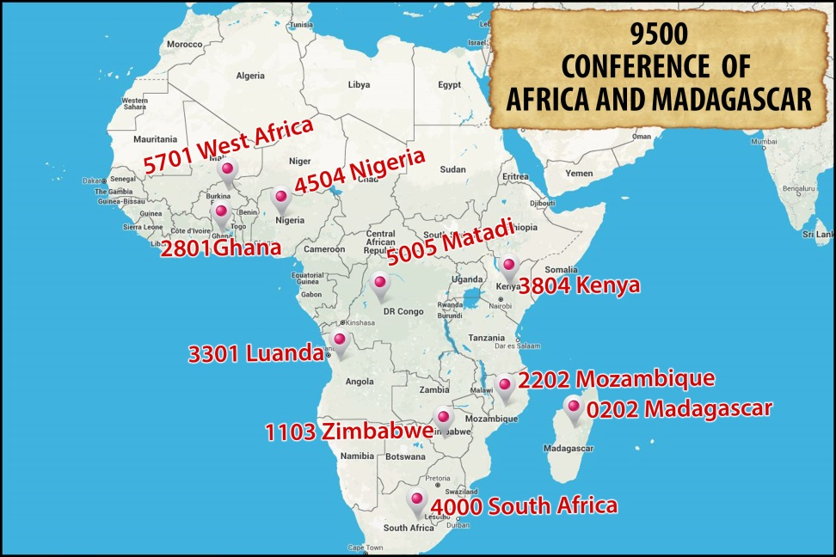

FORMATION
Since its inception in 2010, COREAM has given close attention to the important issue of the formation of Redemptorists in Africa-Madagascar. Whether in the Francophone or Anglophone regions, real efforts have been made to harness our efforts in the area of formation.
1. Common programmes of formation
COREAM, made up of eleven Units (Anglophone and Francophone), has in the context of restructuring voted for and maintained till now four houses of Inter-Unit formation. It should be noted that Africa-Madagascar did not wait for the arrival of COREAM to initiate inter-Unit formation. Such solidarity in formation already existed: Congo-Angola, Madagascar-West Africa, Nigeria-Ghana.
1.1. Initial Formation
A. Anglophone
Novitiate: The common novitiate involves Kenya, South Africa and Zimbabwe. Begun in South Africa, the common novitiate has been relocated since 2015 and is presently in Nairobi, Kenya.
Theologate/Scholasticate: this involves students of South Africa, Kenya and Zimbabwe and it is based in Harare, Zimbabwe.
Besides, the Novitiate and the Theologate of Nigeria have welcome formandi from Ghana for several years.
B. Francophone
Novitiate: The novitiate of the vice-Province of West Africa has been retained as the common novitiate since the first meeting of COREAM at Ouagadougou in 2010. From the beginning it welcomed novices from Congo, Angola and Madagascar. At the moment only Angola participates in the common novitiate with West Africa, because Madagascar opened its own novitiate in September 2012 and welcomes Congolese novices. Hence there are two francophone novitiate houses, one official (Fada N'Gourma) and the other ad experimentum because of the growing number of Malagasy novices.
Theologate/Scholasticate: The first meeting of COREAM voted to recognize two houses of common formation, Ouagadougou and Kinshasa. In fact this project has not got off the ground. Only Angola, since the academic year 2012-13, has joined the Vice-Province of West Africa for common formation.
N.B. Although COREAM has set up four houses of common formation, it must be said that the other stages of formation to Redemptorist life take place in the respective Units. These are, vocational promotion, postulancy and pastoral placements.
1.2. On-going formation
As everyone knows, formation is a life-long process. From this point of view, the Units of COREAM pay particular attention to the on-going formation of the confreres. We can list the following achievements of common formation in COREAM:
- Formation of francophone formators, a course run by the General Secretariat of Formation in 2012 and 2013 at Ouagadougou and Madagascar; a similar course for the Anglophone formators in 2014 and 2015, at Lagos and Accra.
- A course in Redemptorist Spirituality for Francophones, held in Rome by the Centre for Spirituality (September 2013).
- Formation of bursars at Ouagadougou (Oct 2012), Nairobi (2013), Abuja (2013), Congo (2015).
- Formation in Justice Peace and Reconciliation, Nairobi (2014).
- Formation in leadership (CORAT-Kenya 2011; Zimbabwe 2013).

2. Inter-Conference common formation programmes
At the moment there is no common formation between COREAM and the other Conferences. All initial formation takes place within COREAM which has its own structures. Note however, that there was a collaboration between the Conference of Europe and COREAM in terms of the novitiate.
There is no common programme of on-going formation. However, many confreres from COREAM have followed specialized courses in Europe (Conference of Europe) and in America (Conferences of America, North and South). These initiatives are the responsibility of the major superiors of the Units concerned, in conjunction with the Provincials of the mother Provinces or with the Superior General if it involves the Higher College.
3. Concerns of common formation programmes
The preoccupations and needs of common formation are of different sorts:
a) The major preoccupation is the effective functioning of the houses of common formation. There are economic constraints and a lack of goodwill which prevents us harnessing our forces. Example: in COREAM, made up of eleven Units, we have two novitiates and three theologates for the Francophones and two novitiates and two theologates for the Anglophones.
b) The question of finances. Formation is extremely expensive and requires lots of funds. There is the cost of travel from one Unit to another, especially if there are many students; then there is the upkeep and maintenance of the houses.
c) The problem of formators. The Units involved in formation do not easily make their confreres available to the common houses of formation.
d) The administrative procedures are slow and difficult (visas, passports, travel).

4. Challenges
The preoccupations and needs of common formation become themselves the difficulties:
- The challenge of the quality of the formators
- The lowering of the intellectual standard of candidates for Religious Life
- The lack of adequate structures.
- The lack of formation for formators.
- The lack of financial resources.
- The diversity of cultures and mentalities.
- Formation for Redemptorist Religious Life.
- The difficulty of setting up houses of common formation.
- A clericalism that undermines the vocation for Brothers.

5. Ratio formationis
With the setting up of houses of common formation, a Ratio Formationis is being devised by the Formation Secretariat of COREAM. The goal is to have for all the Units a clear orientation for the different stages of formation. In addition to the Ratio there must be added the contracts between the different Units having formation in common. The Anglophone contract has already be signed and the Francophone text is in the process of being signed and adopted.
6. Lay partners
COREAM did set up a Commission for the Laity but unfortunately this commission did not function. This explains the lack of orientations, guidelines or resources for collaboration with the laity.
However, in most of the Units there are lay partners. To adequately accompany them there are statutes and programmes of formation in place.
At the level of COREAM there has not yet been any meeting with lay partners, given that the commission is not operational.

